Design Document

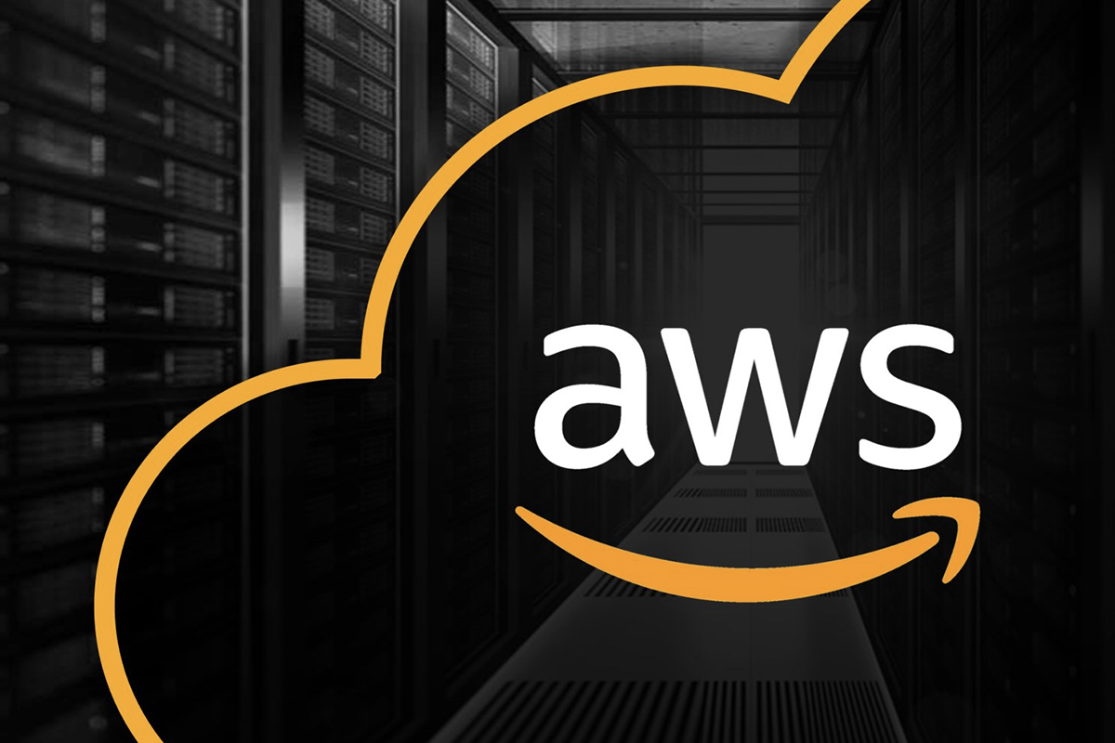

Table of contents

**1. Introduction 2**

1.1 Context 2

**2. Agreements 3**

**3. Requirements 4**

**3.1. What should the system be able to do 6**

**4. Network drawing and description 7**

**4.1. Description of the services 7**

**5. Analysis 8**

5.1 Stakeholder analysis 8

5.2 Goal 8

**6. Technical design 8**

# 

# **1. Introduction**

## 1.1 Context

In countries with very high healthcare needs, there's a big issue: the healthcare system falls short. Even though groups like Doctors Without Borders and the Red Cross work really hard to provide life-saving medical help, they face a big problem. They have to deal with a ton of paperwork every day, which is a lot of work. This paperwork makes things even harder because it can be confusing, and important medical records might even get lost. This adds extra stress to their already limited resources.

Our main goal is to reduce the use of paper for keeping records. This will make it much better for patients in need and save a lot of time and resources. To do this, we're creating a flexible and easily usable system that can be accessed on any machine that is able to access the internet.

We also strive to assist medical professionals by tackling the issue of too much paperwork. We plan to do this by using modern technology. Our goal is to provide them with the tools and support they need to deliver faster, more effective, and potentially life-saving care to those who need it the most. Through this project, we want to make healthcare more accessible in the world's most vulnerable areas.

# **2. Agreements**

* Multi region data storage
* Data/Information is only stored within Europe.
* Data shared by the medical staff.
* Database for patient information/Medical history and bucket for file storage

# **3. Requirements**

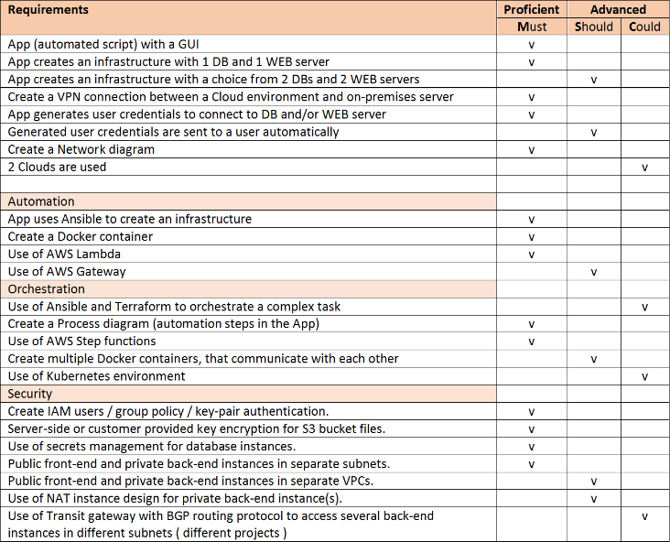

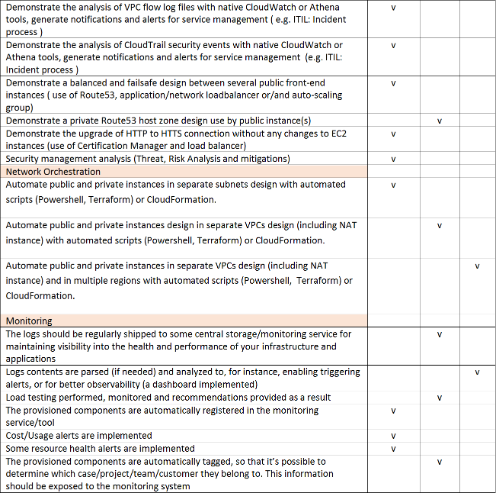

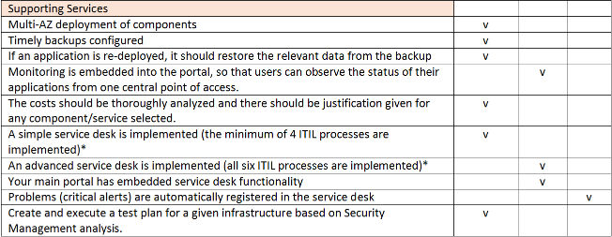

## 3.1. What should the system be able to do?

1. **Stability**: In regions with limited access to stable infrastructure, ensuring the reliability and robustness of our system is paramount. We will design the infrastructure to function under challenging conditions, including unreliable power sources and intermittent network connectivity.
2. **Availability**: Healthcare professionals need access to patient data 24/7, regardless of their location or the time of day. Our system will be engineered to provide uninterrupted access to medical records, even in remote and resource-constrained areas.
3. **Security**: Protecting sensitive medical information is of utmost importance. We will implement stringent security measures to safeguard patient data, ensuring that it remains confidential and compliant with international data protection standards.
4. **Scalability**: As the demand for medical assistance can fluctuate dramatically during crises, our infrastructure will be designed to scale up or down rapidly in response to changing needs. This flexibility will enable medical teams to efficiently manage patient data regardless of the mission's size.
5. **User-Friendly Interface**: To ensure that healthcare professionals can easily access and update patient records, we will develop an intuitive and user-friendly interface. Training requirements will be kept to a minimum to facilitate rapid deployment.

# **4. Network drawing and description**

## 4.1. Description of the services

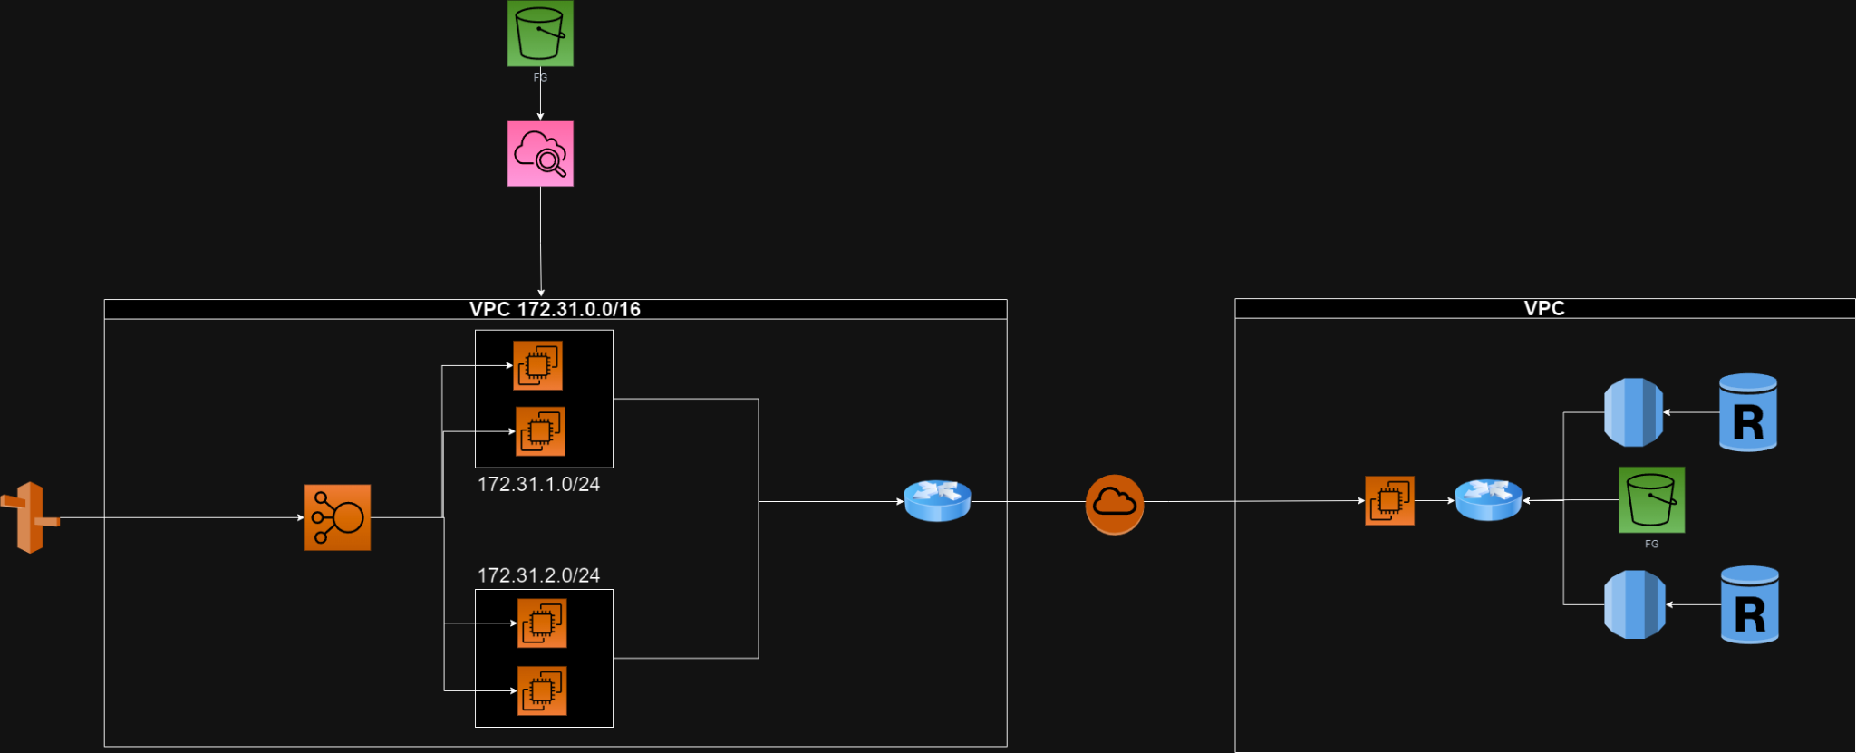

Above you see the **VPC** (Virtual private cloud) design diagram we have made. In this diagram we have structured the infrastructure with **2 VPCs**: the main VPC holds most of the infrastructure.

The main VPC is split into 2 subnets, these hold the **ec2** instances that we will be running. The instances run in these subnets and share the same “**NIC**” (Network Interface Card); the load between the two subnets will be split by a load balancer and the main traffic will come from **route 53**. Data for the ec2 instances is managed by Amazon RDS databases one of the databases will be in the same VPC region and a read backup will be located in another region for backup purposes, the use of s3 storage buckets, this will many be used for storage of images and other miscellaneous data. The whole system will be monitored by **AWS CloudWatch**, so we can keep an accurate monitoring and control of our services.

# 

# **5. Analysis**

## **5.1 Stakeholder analysis**



Lee is a volunteer for the red cross and is a medical doctor based in Burkina Faso. Part of his job is to check up on his patients and do clinical walkthroughs. He has patients in several countries.

## **5.2 Goal**

**Main objectives / motivations:**

Lee deals with a lot of paperwork for his patients such as X-Ray images, CAT scans, prescriptions. Throughout his interactions with his patients, he concluded that the paperwork involved could be minimised. Since Lee works in several countries and must deal with a lot of patients, he could make use of “healthcare on the move” and reduce that paper trail and have online access to records from anywhere. This allows him also to update records and create them for patients, saving time.

# **6. Technical design**

6.1